Original article
Title of the Article
Andrew A Author¹, Ben B Author², Connor Author³
¹ Full name of the organization (City, Country)
² Full name of the organization (City, Country)
³ Full name of the organization (City, Country)
e-mail
Abstract (200-250 words)
It briefly states the purpose of the study, the main results and the main conclusions of the research. The structure of the abstract is as follows.
Introduction. The scientific problem and objectives of the work are identified. The topicality of the research issues is described, and the gap in scientific knowledge that gives the basis for the research is indicated.
Materials and Methods. The methods and techniques used, or procedures for obtaining scientific knowledge are presented.
Results. Specific author's research results are given briefly, the most significant results, attractive to the reader and the scientific community are described.

Discussion and Conclusion. The key results are briefly discussed. Their novelty is evaluated, as well as the possibility of applying the findings in real practice.
Keywords: (5-10). They should reflect the main provisions, achievements, findings, terminology of the research. The list of keywords can also include phrases of 2-3 words, but no more than 4 such phrases
Acknowledgements. In this section, the authors express their appreciation to colleagues for their help, their gratitude for the financial support of the study.
For citation. Author AA, Author BB, Author C. Title of the Article. Advanced Engineering Research (Rostov-on-Don). year;volume(issue):pages. doi

Introduction. (1-2 pages). It presents statement of a scientific problem, its urgency, connection with the major tasks that need to be solved, emphasizes its significance for the development of a certain branch of science or practice. The introduction should contain information that allows the reader to understand and evaluate the results of the research presented in the article. The author should first of all state the common theme of the study, identify problems that have not been solved in previous studies, which this article is designed to solve. In addition, it expresses the main idea of the publication, which significantly differs from current ideas about the problem, complements or deepens already known approaches to it. The attention is drawn to the introduction of new facts, conclusions, recommendations, and patterns into scientific circulation. The objective of the article follows from the formulation of a scientific problem.
Materials and Methods. (1-2 pages). This section describes the process of organizing the experiment, the methods and equipment used; provides detailed information about the object of research; indicates the sequence of the study, and justifies the selection of methods used (observation, survey, testing, experiment, laboratory experience, analysis, modeling, etc.).
Results. In this part of the article, the author's systematized analytical and statistical material should be presented. The results of the conducted research should be described sufficiently fully, so that the reader can trace its stages and assess the validity of the conclusions made by the author. This is the main section, the purpose of which is to prove a working hypothesis (hypotheses). If necessary, the results are confirmed by illustrations (tables, graphs, figures), which represent the source material or evidence in a contracted form. It is critical that the illustrated information does not duplicate the information already given in the text. It is desirable to compare the results presented in the article with previous works of both the author and other researchers in this field. Such a comparison can emphasize the novelty of the work done, increase its objectivity. The results of the study should be presented briefly, but contain enough information to evaluate the conclusions made. The selection of these data should also be justified.
Discussion and Conclusion. Conclusion contains a brief statement of the research results. It summarizes the basic ideas of the body of text. Repetitions of the material presented should be rephrased. In this section, it is necessary to compare the obtained results to the objective of the study stated at the beginning of the work. The results of comprehension of the topic are summarized; conclusions, generalizations and recommendations arising from the work are made; their practical significance is emphasized; and the main directions for further research in this area are determined. In the final part of the article, it is desirable to include attempts to forecast the development of the issues considered.

Example of a figure:
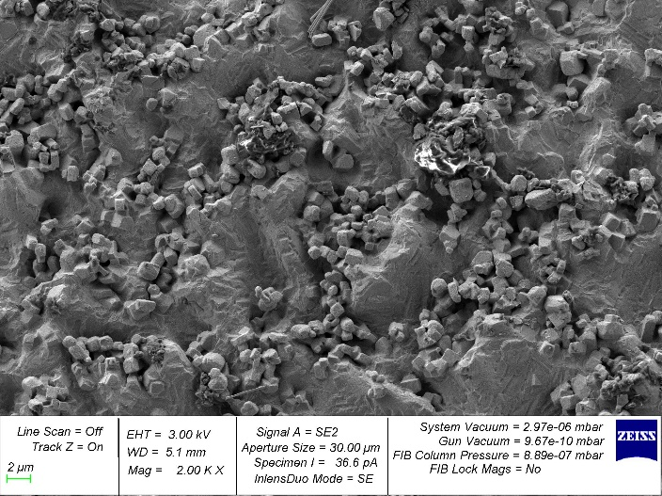 | 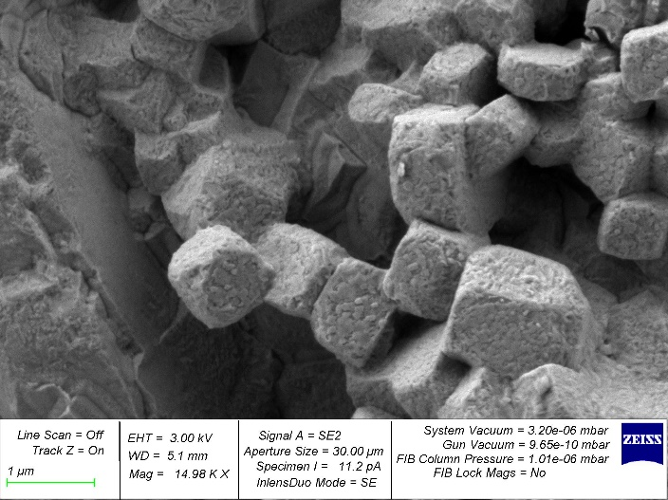
a) | b)
Fig. 1. Caption of the figure:
a — caption; b — caption

Examples of equations:

. (1)
$+\iint_{S}{\left(p_{i}δu_{i}+σ_{0}δφ+B_{0}δξ\right)dS}=0$, (2)

Example of a table:

Table 1
Caption of the table

References

The list of sources used (from 15 to 20) is drawn up in accordance with the requirements adopted in the Journal using the Vancouver citation style. The reference list indicates only sources (articles, books, monographs, patents, dissertations, etc.) that have authorship. References to anonymous electronic sources on the Internet, state standards, statistical reports, articles in socio-political newspapers and magazines, regulatory documents and other sources not signed by the authors are indicated in page-by-page footnotes and are not included in the reference list.

Footnotes are numbered and placed page by page. It is necessary to refer primarily to original sources from scientific journals included in global citation indexes. Of these, over the past 3 years — at least 70%, foreign — at least 10%. When describing the source, its DOI should be specified.
References to articles accepted for publication, but not yet published, must be marked with the words “in print”; authors must obtain written permission to refer to such documents and confirmation that they have been accepted for publication. Information from unpublished sources should be marked with the words "unpublished data/documents", the authors must also draw written confirmation of the use of such materials.

Examples:
1. Paolo Gaudenzi. Smart Structures: Physical Behavior, Mathematical Modeling and Applications. New York: John Wiley & Sons; 2009. 194 p. https://doi.org/10.1002/9780470682401
2. Qader IN, Kok M, Dagdelen F, et al. A Review of Smart Materials: Researches and Applications. El-Cezeri Journal of Science and Engineering. 2019;6(2):755–788. https://doi.org/10.31202/ecjse.562177
3. Novatskii V, Shachnev VA. Ehlektromagnitnye ehffekty v tverdykh telakh. Moscow: Mir; 1986. 160 p. (In Russ.)
4. Levi MO, Kalinchuk VV. Some Features of the Dynamics of Electro-Magneto-Elastic Half-Space with Initial Deformations. In: Proc. 2017 Dynamics of Systems, Mechanisms and Machines (Dynamics), IEEE. 2017. P. 262–266. https://doi.org/10.1109/Dynamics.2017.8239478
5. Bhadeshia HKDH. Kirkendall Effect. University of Cambridge. URL: http://www.phase-trans.msm.cam.ac.uk/kirkendall.html (accessed: 10.02.2023).
6. Kurbatova NV, Nadolin DK, Nasedkin AV, et al. Finite element approach for composite magneto-piezoelectric materials modeling in ACELAN-COMPOS package. In book: Analysis and Modelling of Advanced Structures and Smart Systems. 2018;81:69–88. https://doi.org/10.1007/978-981-10-6895-9_5
7. Ghatak S. Immunization Testing System. US Patent No. 10,788,482. 2019.
8. Colbi Borchetta. Experimental Investigation of Roughness and Blowing Effects over Ablator-Like Surfaces. PhD (Engineering.), diss. Lexington, Ky. 2022. 203 p.

About the Authors:
Name A Surname, Academic degree, Position, Department, Full official name of the organization (Full postal address, city, postcode, country), ResearcherID, ScopusID, ORCID, e-mail
Name B Surname, Academic degree, Position, Department, Full official name of the organization (Full postal address, city, postcode, country), ResearcherID, ScopusID, ORCID, e-mail
Name C Surname, Academic degree, Position, Department, Full official name of the organization (Full postal address, city, postcode, country), ResearcherID, ScopusID, ORCID, e-mail

Claimed contributorship:
Authors need to indicate the actual contribution of each co-author to the work performed. The procedure for specifying the authors and co-authors of the article is agreed by them independently.
Example:
AA Author: academic advising; basic concept formulation; research objectives and tasks; discussion of the results; text preparation; formulation of conclusions. BB Author: planning and organization of experiments; analysis of the results obtained; correction of the conclusions. CC Author: preparation of the experimental base, samples and equipment; computational analysis; discussion of the results.

Conflict of interest statement: the authors do not have any conflict of interest.

All authors have read and approved the final manuscript.

